NETAJI SUBHAS UNIVERSITY OF TECHNOLOGY

Machine Learning

PROF: MR. GAURAV SINGAL SIR

LAB-01 ML

SNEHA GUPTA

2021UCA1859

Exercise answer 1

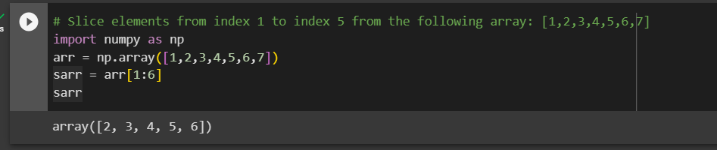

Exercise answer 2

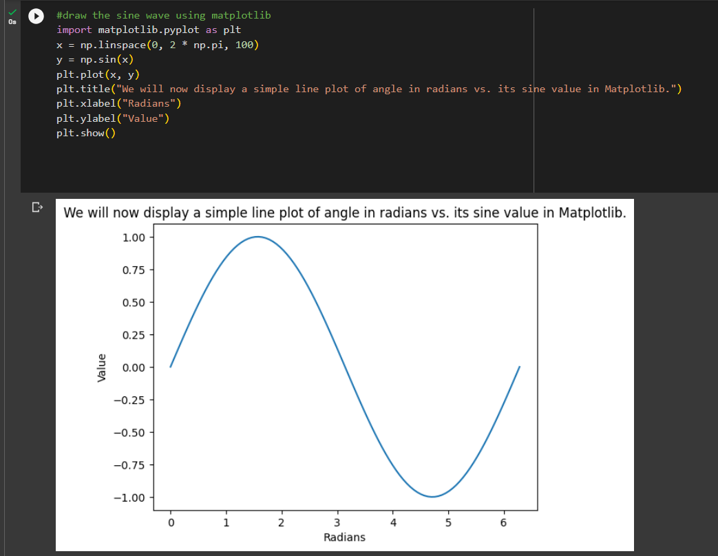

Exercise answer 3

